SENECA COLLEGE OF APPLIED ARTS AND TECHNOLOGY

FACULTY OF CONTINUING EDUCATION
FINAL EXAMINATION

Winter 2025

SUBJECT NAME: INTRODUCTION TO PROGRAMMING USING C

SUBJECT CODE: DSA456V1B

EXAMINATION DATE: April 9th, 2025

INSTRUCTOR NAME: VERIA HAVARY-NASSAB

TIME ALLOTTED: 3 HOURS

MARKS ALLOTTED: 100

WEIGHTING: 30%

SPECIAL INSTRUCTIONS:
Exam Books: Required: Not Required: X
Exam Aids: Permitted: Not Permitted: X
Exam Question Paper: Returned: Not Returned: X

Approved by
______________________________________

Academic Policy Section 9:
Engaging in any form of academic dishonesty to obtain any type of advantage or credit is an offence and will not be tolerated by the College. Such offences under this policy include, but are not limited to, cheating, plagiarism, falsification, impersonation, misrepresentation and procurement.

TOTAL MARKS: 100
- Short answer [20 marks]:
answer the following questions in no more than one paragraph:
  - Given a linked list with sorted values, explain why the big O performance of a search will be will O(n)and not O(log₂(n)). [5 marks]
  - Assume you are sorting an array in a descending order, by creating a binary heap from the array (using heapify process) and then removing each element from the heap and putting it at the back of the array.
which of the min-heap or max-heap do we need to use and why?
[5 marks]
  - Sort the following performance functions from SLOWEST to FASTEST or most unfavorable to most favorable (no reasoning needed).
For any of them, name an algorithm that runs with that speed (if you know one)
[10 marks]
O( log₂(n))
O(n√n)
O(n²)
O(log₃(n))
O(n Log₂(n))
O(√n)

- What is the T(n) and O(f(n)) [big-O performance] for a recursive function that follows the following recursive equation
T(n) = 2 + 2*T(n/4)
Hint 1: 2 + 4 + 8 + 16 + … 2^k = 2^(k+1) -2
Hint 2: 2^[Log₄(n)] = n^[Log₄(2)] = sqrt(n)
please follow all the steps. Any jumping to the final answer without proper mathematical conclusion, will be an incomplete answer
[15 marks]
- Draw 2 complete binary trees with 7 and 16 nodes.
  - What is the height of each tree?
  - What is the depth of the last node in each of the above trees? (last node is the leaf node that can be removed, and the tree will remain a complete binary tree)
  - Put some random numbers in the nodes of your above 16-node complete binary tree. Then list the node values in a post-order, and breadth-first manners [15 marks]

- Create a max heap (larger the value, higher the priority) by inserting these values in order given: 8 9 12 4 5 7 11 4 10
Feel free to include the final heap (and not the mid-step heaps if that’s more convenient)
Remove two numbers from the heap, identify the removed numbers and draw the heap after each removal. [15 marks]

- For the graph below:

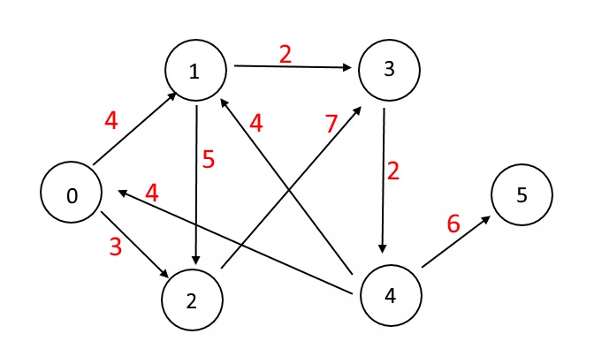
Answer the following questions [15 marks] :
  - Build the adjacency matrix
  - Build the adjacency list
  - Is there a path from 0 to 1? What is(are) the cost(s) of the path(s)?
  - Is there a cycle in the graph? Identify the cycle.
  - What’s the shortest path from 1 to 0?

- Create a Binary search tree (BST) by inserting these values in order given:
5, 3, 6, 2, 8, 4, 9, 7, 11.
Now add a value to each node that reflects the height balance of the node using the AVL tree approach. Identify the nodes that need to go through a rotation to keep the tree balanced. [20 marks]

